Database for the HR Department of the

Luke Foundation Inc.



Created by:

Allen Brent Aledo, Manuel Balbuena Jr., Frank Henry Evangelista, Mark David Ingal, Kiana Alessandra Villaera

Adviser:

Ma’am Ashlyn Kim Balongcod

Table of Contents

1. Introduction – brief description of the system and what service it provides

Glossary – definition of some technical terms used in the document

1. Database Structure – ER Diagram, Data Dictionary
2. User Interface Architecture – description of the front-end user interface
3. Appendix (reference forms, documents, etc.)

1. Introduction

The project is to create an instrument for Luke Foundation HR department to help them organize the department easily through databases. The system provides several features that were requested by the organization. The foundation has organizers hence the system has records of organizers together with the information for each and it can search, edit, add another record and delete. The system also has a calendar where activities of the foundation are shown and can also search, sort by month and year, edit, add activity and delete. For the attendance of the staff, it caters the records of the employees with their corresponding number of leave. Overall, this database system will make recording, editing and deleting of information organized and easy for the HR Department of the Luke foundation. This will be further explained within this document.

1. Glossary

Database - a collection of information that is organized so that it can be easily accessed, managed and updated

ER Diagram - an entity-relationship diagram (ERD) is a data modeling technique that graphically illustrates an information system’s entities and the relationships between those entities

Xampp - is a Free and Open Source Cross-Platform Web Server Solution Stack. It comes with Apache Web Server, MySQL Database, PHP and Perl Programming Languages as a local web server which provides the suitable environment for PHP, SQL and more.

PK - primary key consists of one or more columns whose data contained within are used to uniquely identify each row in the table. You can think of the primary key as an address.

FK - a foreign key is a set of one or more columns in a table that refers to the primary key in another table.

1. Database Structure

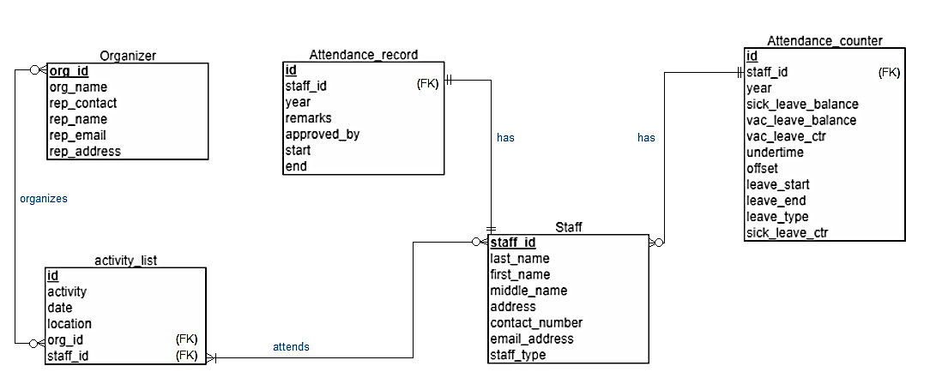

ER Diagram:

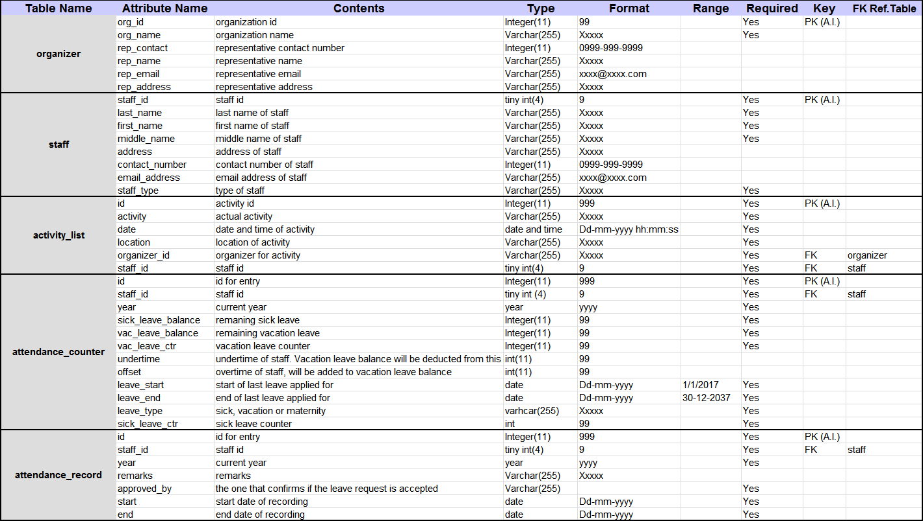 Data Dictionary:

User Interface Structure

* The homepage includes the links to the different sections of the Human Resource Department

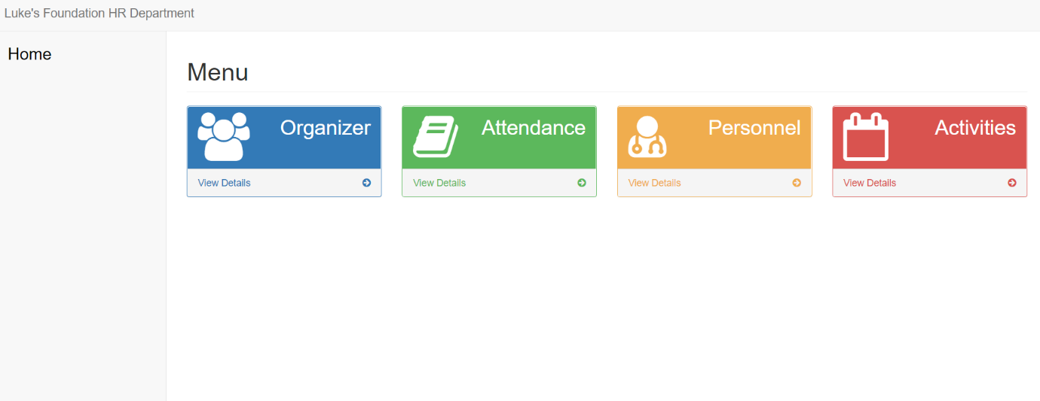

* Dynamic webpages i.e. the UI adjusts depending on the window size

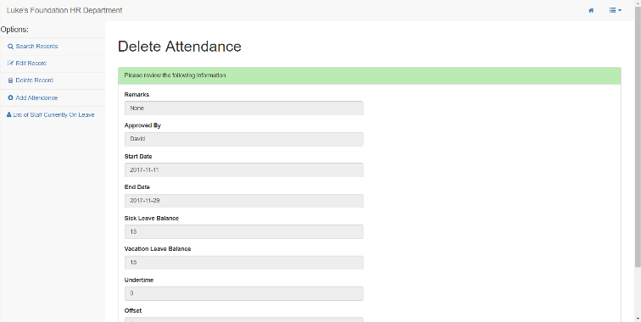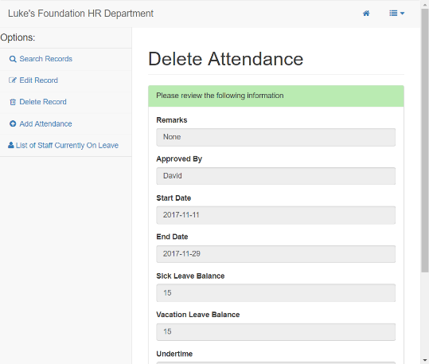

* Uses color-coded buttons i.e. green for update, red for delete.

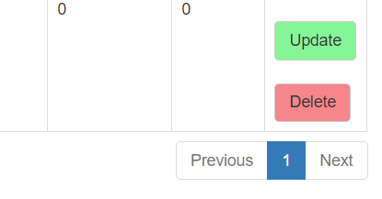

* All webpages (except the homepage) have a header which includes a Home button and a dropdown navigation linked to the other sections

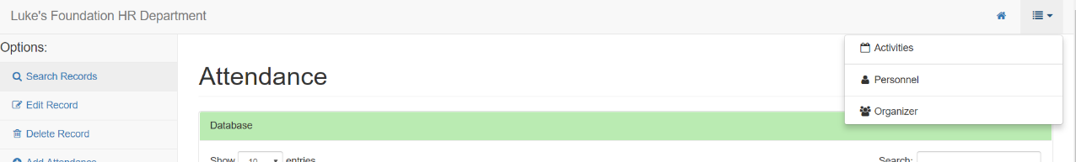

* Text-fields exhibit error-checking features such as the Contact number text-field and the Email Address text-field.

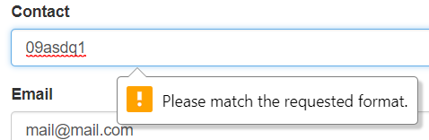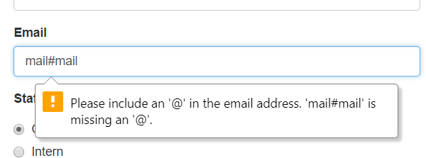

* Common functions include: Search, Edit, Delete, and Add

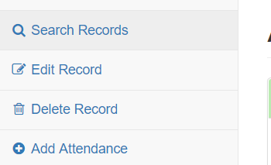

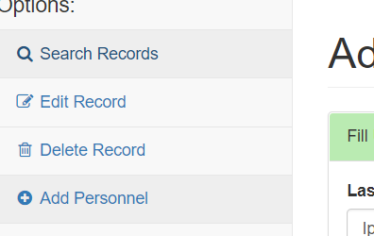

* Certain sections have special function like showing list of staff that are currently on leave and a calendar of activities

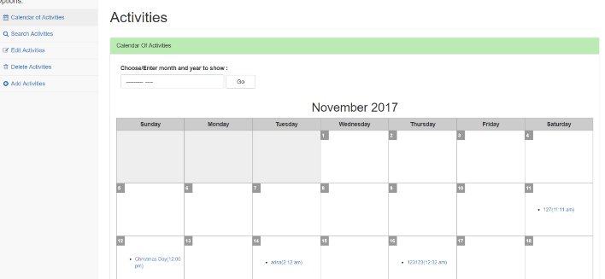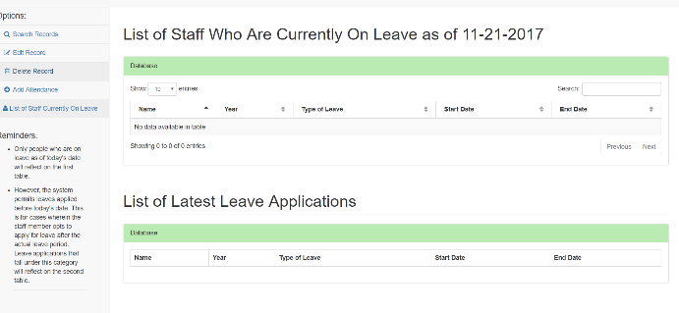

Appendix

References:

<http://searchsqlserver.techtarget.com/definition/database>

<http://a5theory.com/xampp-server-what-is-xampp-server/>

<https://www.targetintegration.com/uncategorized/what-is-xampp>

<https://www.techopedia.com/definition/1200/entity-relationship-diagram-erd>

<https://www.essentialsql.com/what-is-the-difference-between-a-primary-key-and-a-foreign-key/>

Contact:

[mdingal@up.edu.ph](mailto:mdingal@up.edu.ph)

09182876872

Xampp download link:

https://www.apachefriends.org/download.html